PlaceHolder Warehouse Navigation System

Developer Manual

Made by Placeholder©
Weishi Li, Hao Wang, Xinyu Zhang, Junfeng Chen

Table of Contents

Table of Contents 2
Glossary 3
Version History 4
Software Architecture Overview 5
Main data types and structures 5
Major software components 7
Module interfaces 7
Overall program control flow 8
Installation 9
System requirements 9
Setup & Configuration 9
Uninstalling 9
Details of packages, modules, interfaces 10
Data structures 10
Functions and Parameters 13
Input and Output formats 14
Analysis of Algorithms 14
Modification of Algorithms 14
Comparison of Algorithms 14
Development plan and timeline 15
Partitioning of tasks 15
Team member responsibilities 15

Glossary

Term | Definition
Tab Delimited | A file that separates rows of data points with a Tab and columns of data with a return.

Version History

Ver 0.01 updated by 10/12/2021
Write the basic information about the program.
Alpha release 1 updated by 10/19/2021
Add the new functions and classes of the login system
Beta release 1 updated by 11/14/2021
Add the new functions and loading system instead login system
Beta release 2 updated by 11/28/2021
Add the new functions to GUI and fix the function ‘choosePoint’
Final release updated by 12/4/2021
Add the new functions and change the flow chart

Software Architecture Overview

Main data types and structures
Class User has attributes of name, username, id, password, position, and functions of getName, getID, getPosition, getProductPosition.
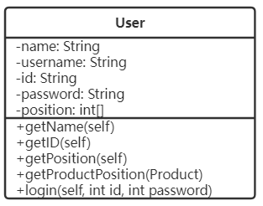
Figure 1 Class User

Class Product has attributes of id, x coordinate, y coordinate, and functions of getID, getPosition.
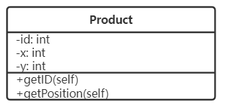
Figure 2 Class Product

Class Map has attributes of width, height, map, and functions of addShelves.
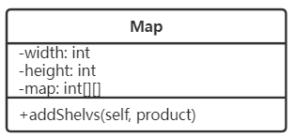
Figure 3 Class Map

Class workerIcon has attributes pex(picture address), h(height), w(width) and functions of _set_pos.
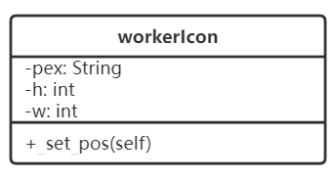
Figure 4 Class workerIcon

Class Gui inherits attributes and functions from python library QWidegt and has attributes and functions as Figure 5.
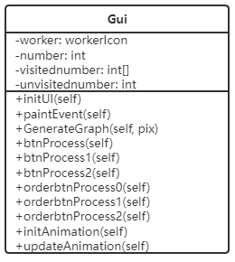
Figure 5 Class Gui

Class Loading inherits attributes and functions from python library QWidegt and has attributes and functions as Figure 6.
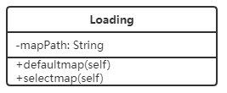
Figure 6 Class Loading

Class Loading2 inherits attributes and functions from python library QWidegt and has attributes and functions as Figure 7.
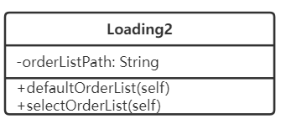
Figure 7 Class Loading2

Class Controller has the functions of show_loading, show_loading2 and show_main.
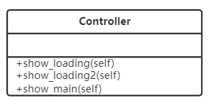
Figure 8 Class Controller

Major software components
This system integrates three components: file loading system, map generate system, navigation system.
Loading system manages map information order list information.
Map generate system receives map information and products information, then generates the layout of products on the map.
Navigation system allows users to find a certain product or multiple products in the warehouse with the cooperation of the map generation system.

Module interfaces
In the final version of the system, classes and functions are defined in the same python file but different parts to satisfy the portability and maintainability.

Overall program control flow
The system first receives the map information and order list information. If the information is inputted correctly, the system reads the map information and generates the layout of the warehouse. Users can now see the map on the screen and decide which product they are looking for. The system checks the product list and generates an optimal route to the product.
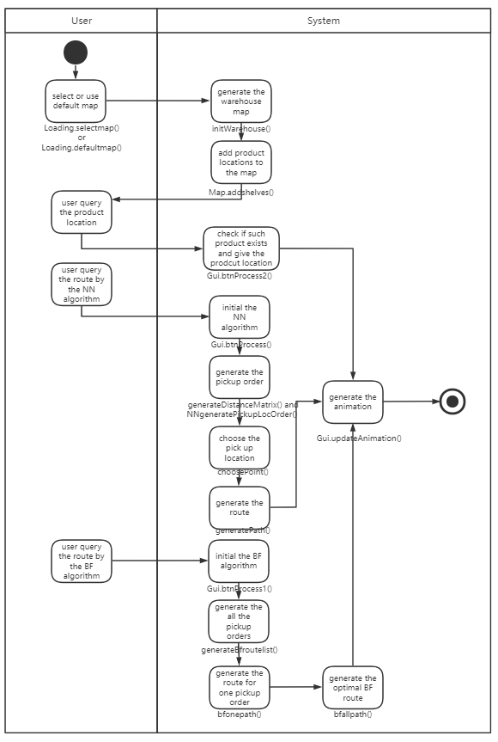
Figure 9 System Control Flow

Installation

System requirements
Win10 64 Bit/ Mac/ Linux
2 GB of RAM
1 GB Hard drive space

Setup & Configuration
Install python3 on windows/mac/linux

Uninstalling
simply just delete .py file

Details of packages, modules, interfaces

Data structures

- Global Variables:
- productDict: store the dictionary of product ID and its location
type: dict{ str: tuple}
- productLocation: store all the locations of the products
type:list [tuple]
- warehouseMap: use 0, 1 to represent the empty space and shelves
type:list [list [int]]
- user: store all the users
type:list [User]
- path: store all the directions of different paths
type:list [list [str]]
- maxHeight, maxWidth: store the map’s height and width
type: int
- graphStartPixel: store where to draw the static map graph background
type:tuple
- pathStartPoint, pathEndPoint: store where the path starts and ends
type:tuple
- pathStartPixel, pathEndPixel: store which pixel to start drawing the path and end the drawing.
type:tuple
- animatedPathPixel: store pixels the animation needs to generate the path
type: list [tuple]

- Class User:
Attributes:
- name: a string corresponding to the user’s real name
- username: a string with the maximum length of 10, created by the user
- id: a string with the maximum length of 5, assigned by the manager
- password: a string with the maximum length of 10
- position([x, y]): an int array corresponding to the user’s real position, the first element is x coordinate and the second element is y coordinate
Functions:
- getUsername(self): return the username of the user
return type: String
- getID(self): return the id of the user
return type: String
- getPosition(self): return the position of the user
return type: Int[] with two elements, the first element is x coordinate and the second element is y coordinate
- getProductPosition(Product): get a Product instance, return the position of the product
return type: Int[] with two elements, the first element is x coordinate and the second element is y coordinate
- Product:
Attributes:
- id: an int type data with the maximum length of 7, assigned by the warehouse system, each product has a unique id
- x: location in x coordinate
- y: location in y coordinate
Functions:
- getID(self): return the product id to the product
return type: int
- getPosition(self): return the xy coordinate position of the product
return type: int[] with two elements, the first element is x coordinate and the second element is y coordinate
- Map:
Attributes:
- width: the length in x coordinate
- height: the length in y coordinate
Functions:
- addShelves(self, product): place a shelf by the product’s location, then the function will be 1
return type: null
- Loading:
Functions:
- layout_init(self): initialize the interface
- pushbutton_init(self): create 2 buttons, one is for selecting map by user, another is for the default map
- selectmap(self): select map files
- defaultmap(self): if the user didn’t select map, the system will run by the default map
- Loading2:
Functions:
    - layout_init(self): initialize the interface
    - pushbutton_init(self): create 2 buttons, one is for selecting order list by user, another is for the default order list
    - selectOrderList(self): select order list files
    - defaultOrderList(self): if the user didn’t select order list, the system will run by the default order list
- Gui(QWidget):
Functions:
- paintEvent(self, event): for an input event, draw the corresponding map towards the product.
return type: null
- GenerateGraph(self, pix): draw the layout of the warehouse
return type: null
- updateAnimation(self): generate the animated path and store it in animatedPathPixel for the workerIcon to follow.
return type:null
- initAnimation(self): display the animation of the workerIcon walking along the path.
return type:null
- btnProcess(self): When a user clicks the search button, this function will be called and it calls generatePath function to generate path directions and stores it in global variable ‘path’, it helps paintEvent function to draw the route. It also calls the updateAnimation function and generateAnimatedPath function to generate the animated path for the workerIcon to follow.
return type:null
6. orderbtnProcess(self):
This function is used to read .txt file and attain product location list, and prepare for generate the path.
return type:null

- Controller(QWidget):
Functions:
- show_loading(self): show the map loading system
return type: null
- show_loading2(self): show the order list loading system
return type: null
- show_main(self): close the login system and show the navigation system
return type: null

Functions and Parameters
- initWarehouse():
This function initializes the map of the warehouse, reads the text file of products, and forms a picture.
- bfs(map, start, end):
This function is used to find a path between two nodes and returns a series of coordinates from start point to destination.
- findNeighbours(map, location):
This function returns the neighbors of one location. We define neighbors as the locations next to(up, down, left, right) this location which doesn't have a shelf on it.
- choosePoint(currentLoc, firstLoc, secondLoc):
This function decides whether to pick up products from up/down/left/right in order to get the shortest path based on current location, the next pick-up product’s location and the pick-up product’s location after next.
- generatePath(bfsPath):
This function is to convert coordinates to directions. It generates a list of “r”, ”l”,”u”, “d” which represent the right, left, up and down direction respectively, and adds this list to the global variable ‘’path’’.
- generateAnimatePath():
This function generates the path that workerIcon will follow.
- combinePath(distance, direction, d, start, pathStr):
This function combines same direction path
- toPathStr(path, idorder):
This function generates the detailed path string.
- generateBfroutelist(node,productLocList,path):
This function will generate the brute force route.
- bfneighbours(bfroute, map):
This function will find the current node’s neighbours.
- bfonepath(node, neighbours, path, distance, end):
This function will calculate path length from current to last node.
- bfallpath(start, end, productLocList):
This function will show the shortest path and distance.
- bffindNeighbours(map, location):
This function will return the neighbors of one location for the Brute Force algorithm.
- NNgeneratePickupLocOrder(start, productLocList):
This function will find the pick-up order of products by the NN algorithm.
- generateDistanceMatrix(productLocList):
This function will generate the distance matrix of every node.
- findDistance(pickupLoc1, pickupLoc2):
This function is used to find the distance between pickup location 1 to pickup location 2.

Input and Output formats
- The users press the “select” button and select a file:
  - function selectmap() and selectOrderList() reads the map dictionary and loads the map file and order list file
- The users enter a productID:
  - Product.getID() gets the id from the product list and the system finds the matched one.
  - Product.getPosition() and User.getPosition() receive the Product instance and User Instance, then get the product position and the worker position.
  - The corresponding functions in the GUI class receive the positions and generate the optimal route.
  - The system creates a GUI instance to show the user the optimal route.

Analysis of Algorithms

Modification of Algorithms
- Brute Force: compared to the original one, we add a timeout limitation. When the time threshold is met, the result will display the temporarily shortest path. Besides, the dynamic starting and ending point is added. The users could input X, Y coordinates as their location.
- Optimized Nearest neighbor: Instead of randomly picking up the first product, Nearest neighbor uses distance matrix to select the first pickup product and then find the next one based on distance. We also have our own pick-up location strategy so that it will make the path shorter.

Comparison of Algorithms
In general, when the order size is small, our algorithm could reach the same optimal result as brute force, and use less time and memory. Also our algorithm can handle large size orders that brute force algorithms can’t. As for time complexity, our algorithm’s time complexity is far less than O(n!). Thus, from above aspects, our algorithm works better than brute force.

Development plan and timeline

Partitioning of tasks
- Design the map generating system.
- Design the loading system.
- Design the Navigation system.
- Design the UI.

Team member responsibilities
Weishi Li: Participated in the route-finding algorithm design, designed the overall program architecture, ensured each part of the user manual is consistent and well-organized. Programmed the Brute Force algorithm and integrated it with the program. Programmed the map select module and location finding module.

Junfeng Chen: Wrote the alpha,beta, final version of the entire program.

Hao Wang: Wrote the class parts of data structures. Tested the basic function, and added some text on the print output, as well as some details such as the title of GUI.

Xinyu Zhang: Wrote the data structures on function. Test environment configuration on different IDE.

